**User Guide**

## User Guide

The user guide is based on the normal workflow of the system

### Login

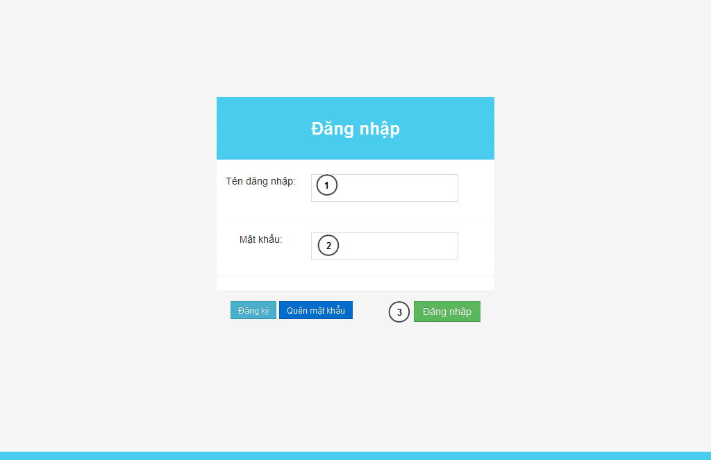

**Figure 84: Login Page**

|  |  |
| --- | --- |
| **Step** | **Description** |
| 1 | Fill UserID to “Tên đăng nhập” textbox |
| 2 | File password to “Mật khẩu” textbox |
| 3 | Press “Đăng nhập” button to login. |

**Table 46: Login Step**

### Admin

#### Set staff

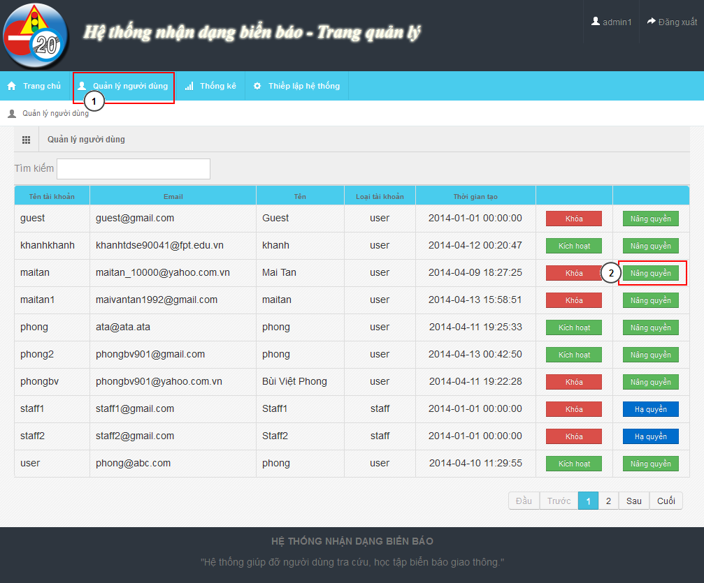

**Figure 85: Account Manage Page**

|  |  |
| --- | --- |
| **Step** | **Description** |
| 1 | “Quản lý người dùng” menu |
| 2 | Find user want to set staff. Click “Nâng quyền” |

**Table 47: Set staff**

### Staff

#### Add new traffic sign

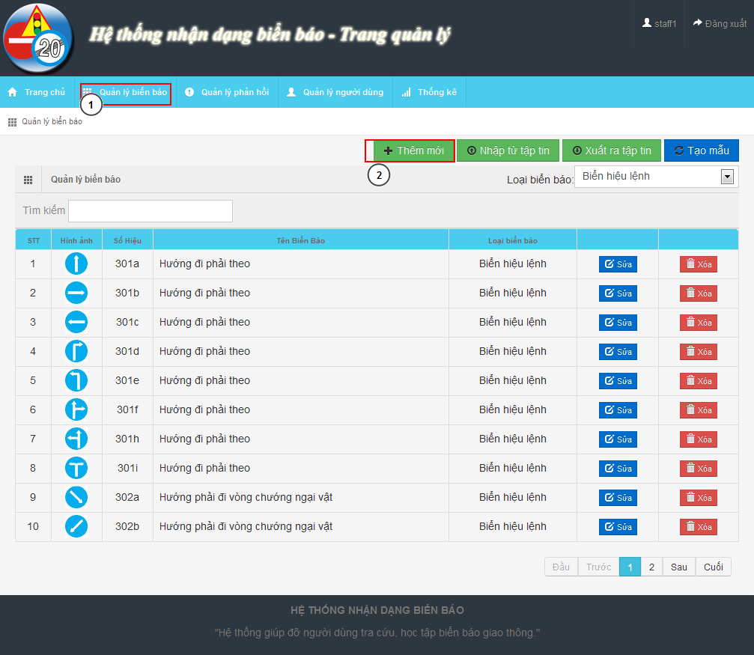

**Figure 86: Traffic Sign Manage Page**

|  |  |
| --- | --- |
| **Step** | **Description** |
| 1 | “Quản lý biển báo” menu |
| 2 | Click on “Thêm mới” button to show Add new modal |

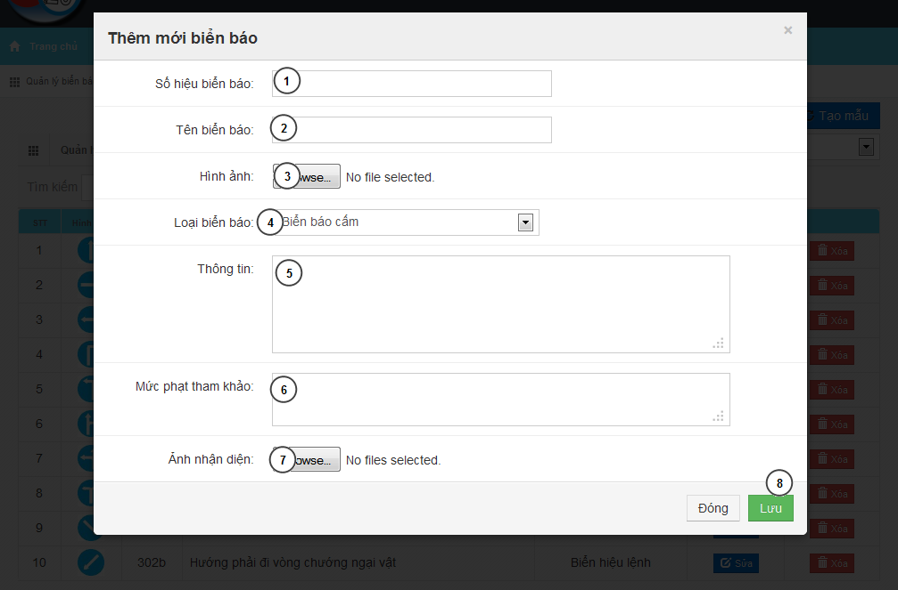

**Figure 87: Add New Traffic Sign Modal**

|  |  |
| --- | --- |
| **Step** | **Description** |
| 1 | Input traffic sign label |
| 2 | Input traffic name |
| 3 | Input traffic image |
| 4 | Select traffic type |
| 5 | Input traffic sign information |
| 6 | Input traffic sign penalty fee |
| 7 | Input train image for traffic sign |
| 8 | Press “Lưu” button to save traffic sign |

#### Fix wrong recognition from report

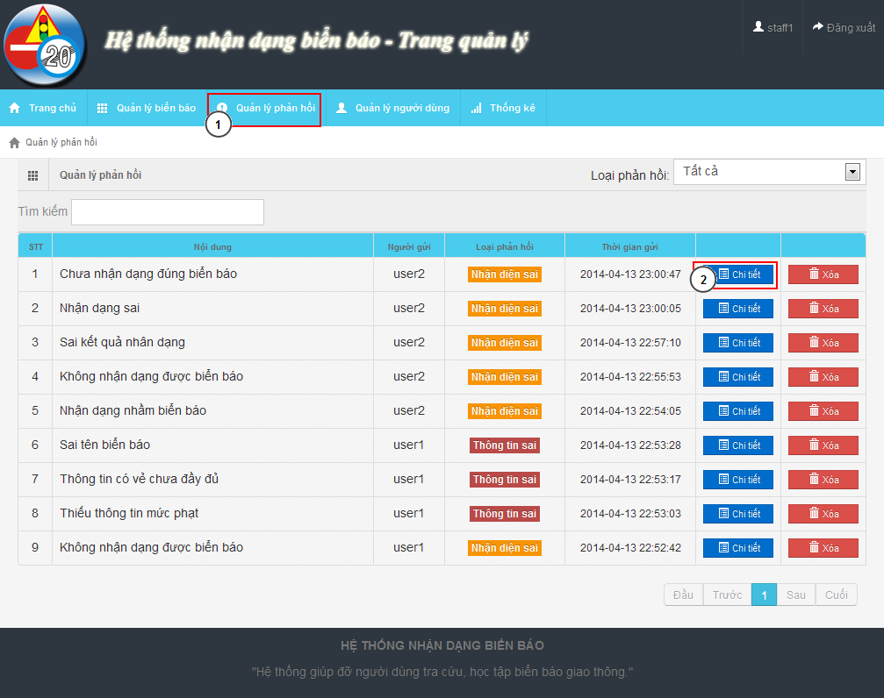

**Figure 88: Report Manage Page**

|  |  |
| --- | --- |
| **Step** | **Description** |
| 1 | “Quản lý phản hồi” menu |
| 2 | Find the report and click “Chi tiết” to show detail of report |

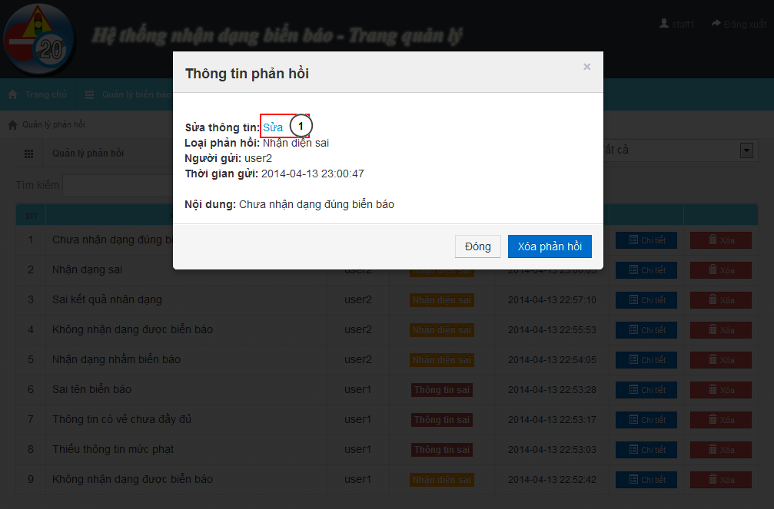

**Figure 89: Report Detail Modal**

|  |  |
| --- | --- |
| **Step** | **Description** |
| 1 | Click “Sửa” to edit the result |

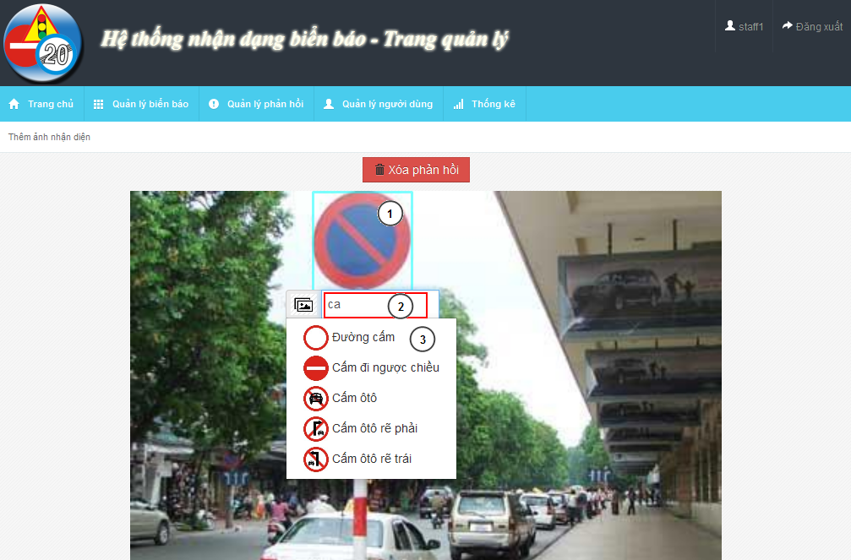

**Figure 90: Edit Wrong Recognition Page**

|  |  |
| --- | --- |
| **Step** | **Description** |
| 1 | Move mouse to the detected area |
| 2 | Input text to find the right traffic sign name |
| 3 | Select traffic sign name match with the image |

### User – Mobile

#### C:\Users\phongbv\Desktop\Do an\screen chot\login.pngLogin

**Figure 91: Login Screen**

|  |  |
| --- | --- |
| **Step** | **Description** |
| 1 | Fill Username. Example: phongbv |
| 2 | Fill Password. Example: 123456 |
| 3 | Click “Đăng nhập” button |

**Table 48: Login Step**

#### Register

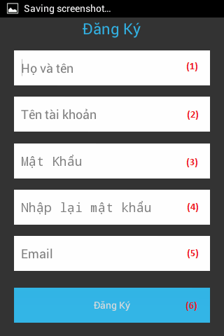

**Figure 92: Register Screen**

|  |  |
| --- | --- |
| **Step** | **Description** |
| 1 | Fill fullname. Example: Bùi Việt Phong |
| 2 | Fill account name. Example: phongbv |
| 3,4 | Fill password. Example: 123456 |
| 5 | Fill email. Format email: abc@example.com |
| 6 | Press “Đăng ký” button |

**Table 49: Register Step**

#### Search Auto

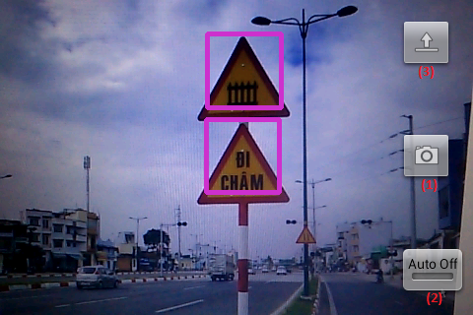

**Figure 93: Search Auto Screen**

|  |  |
| --- | --- |
| **Step** | **Description** |
| 1 | Press button to take picture and wait for result. |
| 2 | Click button switch on or off auto take picture mode. |
| 3 | Press button to select picture from mobile instead of take a picture by camera. |

**Table 50: Search auto step**

#### Search auto result

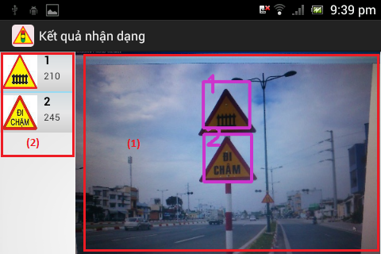

**Figure 94: Search auto result screen**

|  |  |
| --- | --- |
| **Step** | **Description** |
| 1 | Picture was taken by user before. |
| 2 | List result, position match with number in the image. Select one item to view traffic sign detail |

**Table 51: Search auto result step**

#### Search manual

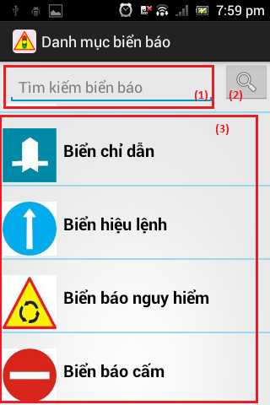

**Figure 95: Search manual Screen**

|  |  |
| --- | --- |
| **Step** | **Description** |
| 1 | Fill search key. Example: “đường cấm”. |
| 2 | Click button to search by traffic sign’s name. |
| (3) | Select one category to view list traffic sign by category. |

**Table 52: Search manual step**

#### C:\Users\phongbv\Desktop\Do an\screen shot\list traffic.pngSearch manual result

**Figure 96: Search manual result Screen**

|  |  |
| --- | --- |
| **Step** | **Description** |
| 1 | Select one traffic sign to view detail. |

**Table 53: Search manual result Step**

#### View traffic detail

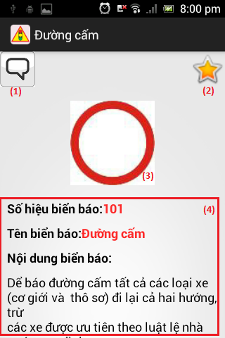

**Figure 97: View traffic detail screen**

|  |  |
| --- | --- |
| **Step** | **Description** |
| 1 | Press this button to report wrong information |
| 2 | Press this button to add or remove traffic sign to favorite |
| 3 | Traffic sign’s image |
| 4 | Traffic sign’s information |

**Table 54: View traffic detail step**

#### C:\Users\phongbv\Desktop\Do an\screen shot\favorite.pngView favorite

**Figure 98: View favorite screen**

|  |  |
| --- | --- |
| **Step** | **Description** |
| 1 | Select one traffic sign to view detail. (Or hold for 1 second, then select “Xóa” to delelte traffic sign from favorite list) |

**Table 55: View favorite step**

#### View history

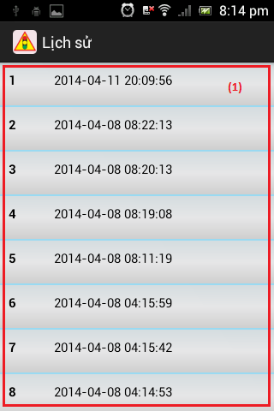

**Figure 99: View history screen**

|  |  |
| --- | --- |
| **Step** | **Description** |
| 1 | Select one row to view search auto result detail. (Or hold for 1 second, then select “Xóa” to delelte result from history list) |

**Table 56: View history step**

#### C:\Users\phongbv\Desktop\Do an\screen shot\feedback.pngSend Report

**Figure 100: Send report screen**

|  |  |
| --- | --- |
| **Step** | **Description** |
| 1 | Enter report content. |
| 2 | Press this button to send report |

**Table 57: Send report step**

#### Setting

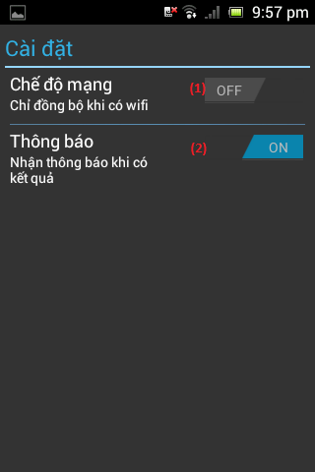

**Figure 101: Setting screen**

|  |  |
| --- | --- |
| **Step** | **Description** |
| 1 | Press this button to turn on or off “synchronize when on wifi only” mode. |
| 2 | Press this button to turn on or off notification when have search auto result. |

**Table 58: Setting step**

### User - Website

#### Search auto

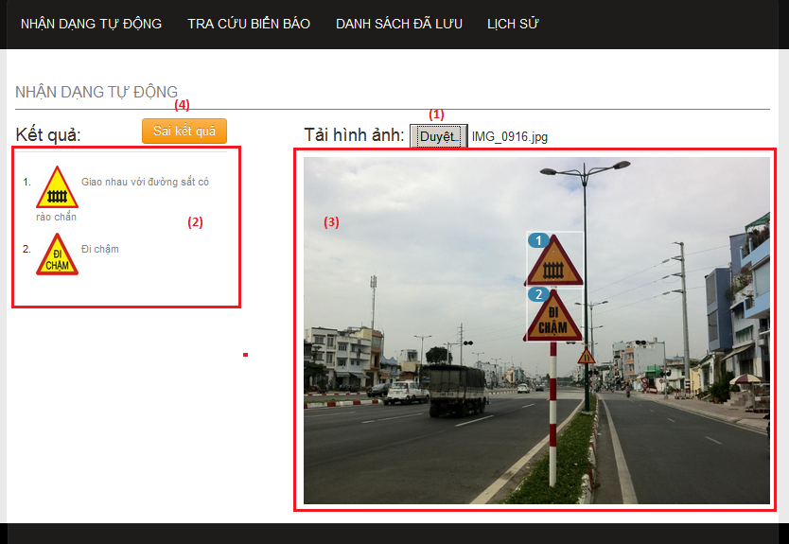

**Figure 102: Search auto page**

|  |  |
| --- | --- |
| **Step** | **Description** |
| 1 | Click button “Chọn tệp tin” to select image for upload and wait for a few seconds. |
| 2 | List result, position match with number in the image. Select one item to view traffic sign detail |
| 3 | Picture was uploaded by user before |
| 4 | Click button “Sai kết quả” to report if the result is wrong. |

**Table 59: Search auto step**

#### Search manual

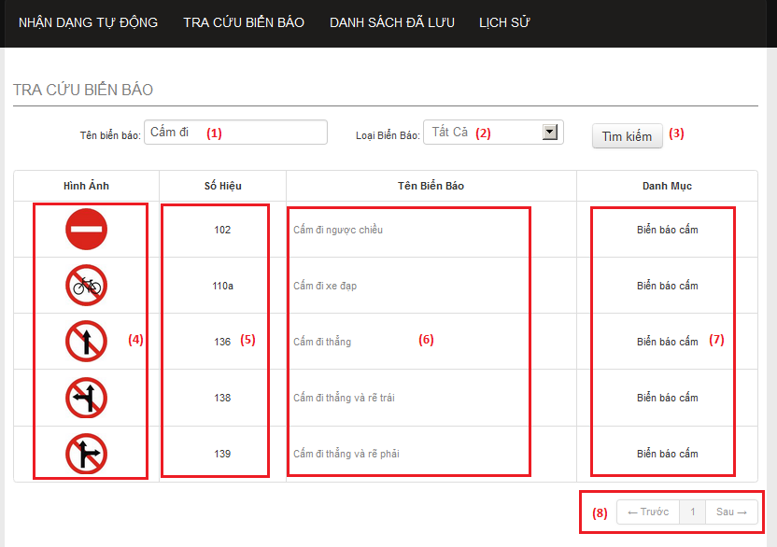

**Figure 103: Search manual page**

|  |  |
| --- | --- |
| **Step** | **Description** |
| 1 | Enter traffic sign’s name. Example: “cấm đi”. |
| 2 | Select one item to choose traffic sign category. |
| 3 | Click button “Tìm kiếm” to search traffic sign. |
| 4 | This column display traffic signs’ image. Click image to view traffic sign detail. |
| 5 | This column display traffic signs’ ID number. |
| 6 | This column display traffic signs’ name. Click traffic sign’s name to view traffic sign detail. |
| 7 | This column display traffic signs’ category. |
| 8 | Select number or “Trước”, “Sau” to view others records in the table. |

**Table 60: Search manual step**

#### View list favorite

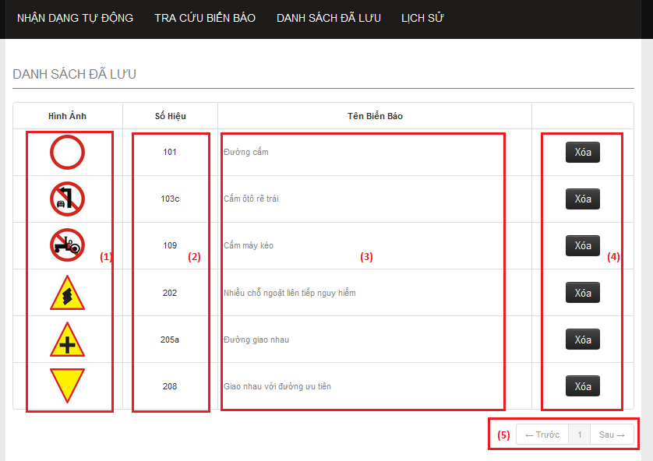

**Figure 104: Favorite page**

|  |  |
| --- | --- |
| **Step** | **Description** |
| 1 | This column display traffic signs’ image. Click image to view traffic sign detail. |
| 2 | This column display traffic signs’ ID number. |
| 3 | This column display traffic signs’ name. Click traffic sign’s name to view traffic sign detail. |
| 4 | Click button “Xóa” to remove one traffic sign from favorite list. |
| 5 | Select number or “Trước”, “Sau” to view others records in the table. |

**Table 61: View favorite step**

#### View list history

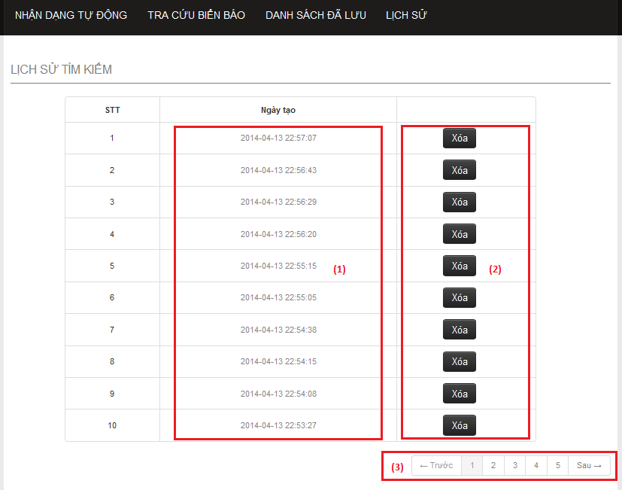

**Figure 105: History page**

|  |  |
| --- | --- |
| **Step** | **Description** |
| 1 | This column display the times when the history was created. Click link to view history detail. |
| 2 | Click button “Xóa” to remove one history from history list. |
| 3 | Select number or “Trước”, “Sau” to view others records in the table. |

**Table 62: View list history step**

#### View history detail

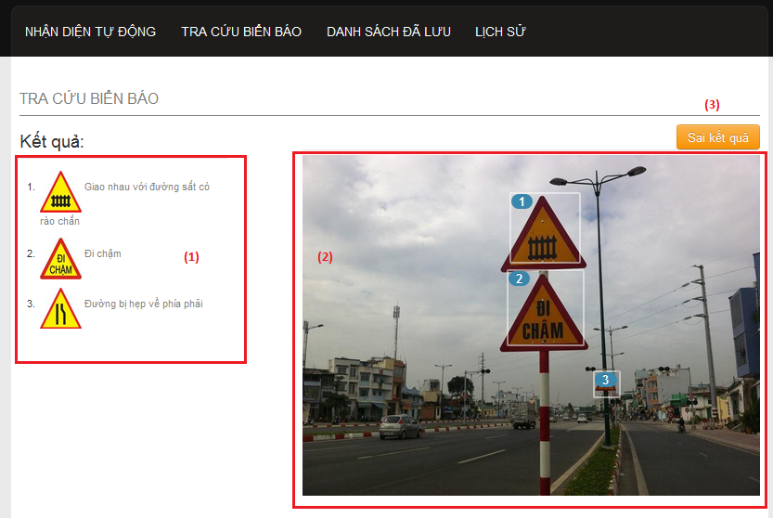

**Figure 106: History detail page**

|  |  |
| --- | --- |
| **Step** | **Description** |
| 1 | List result, position match with number in the image. Select one item to view traffic sign detail |
| 2 | Picture was uploaded by user before |
| 3 | Click button “Sai kết quả” to report if the result is wrong. |

**Table 63: View history detail step**

#### View traffic sign detail

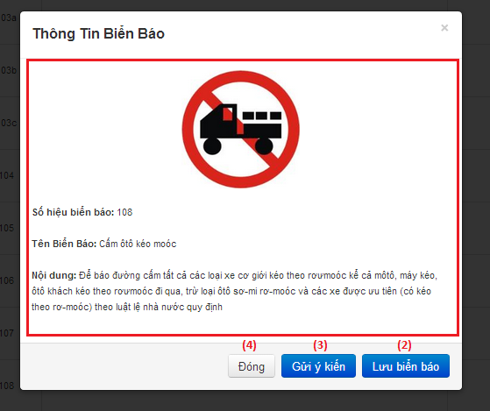

**Figure 107: Traffic sign detail popup**

|  |  |
| --- | --- |
| **Step** | **Description** |
| 1 | Traffic sign’s detail information. |
| 2 | Click “Lưu biển báo” to add traffic sign to favorite list. |
| 3 | Click button “Gửi ý kiến” to report if the information is wrong. |
| 4 | Click button “Đóng” to close popup. |

**Table 64: View traffic sign detail step**

#### Send report

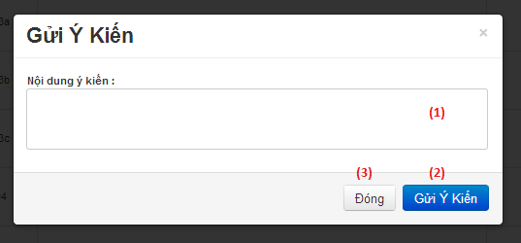

**Figure 108: Send report popup**

|  |  |
| --- | --- |
| **Step** | **Description** |
| 1 | Enter report content. |
| 2 | Click button “Gửi ý kiến” to send report. |
| 3 | Click button “Đóng” to close popup. |

**Table 65: Send report step**

## User Notice

### Image Data Notice

* Each traffic sign should have at least 5 images for train image.
* The image should be in good condition, not have too much noise, or hide by another object.

Example of good image data:

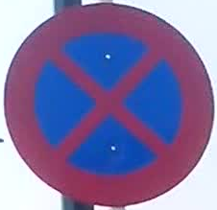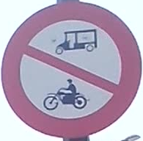

Sample data of a traffic sign about 5-10 images:

* 60% taken from front of traffic sign.
* 40% taken from to side of traffic sign about 30 degrees side long.

Example of a good sample data set:



Avoid using not clear images like these:

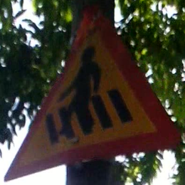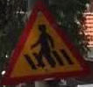

### Take image to search

The below is recommend for the best image when search auto:

* Position and angle:

The best position and angle is font up the traffic sign. In the worst case, make sure you have an angle about 30 degree in front up the traffic sign.

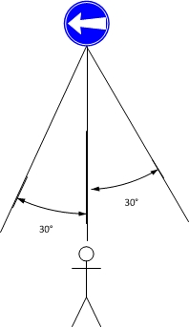

**Figure 109: Position and angle 1**

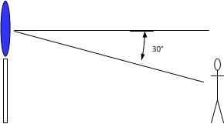

**Figure 110: Position and angle 2**

* The size of traffic sign in image:

By default the best size of traffic image is from 1/10 to ¼ of the width of image.

